Detailed instructions for EventFinder
This program is useful for detecting “events” ie deviations from noise in a 1D trace. It has been used for analysing nanopore current levels but can be applied to other 1D time variables.
Note on resolution: The program will work best at a resolution of 1600x900 and with the text size in windows set to 100%.

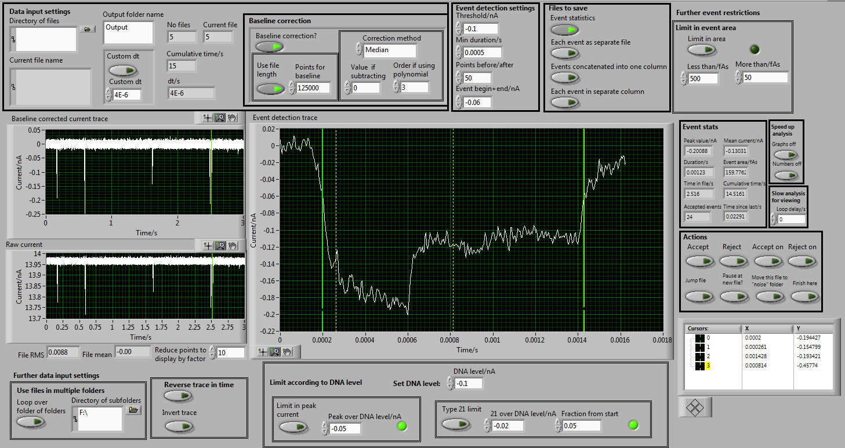
Data input settings:
- Directory of files. Here you input the folder containing all the files that are to be analysed. Each file should be <~50MB or the program may crash. Alternatively at the bottom of the screen there is an option of looping through a folder containing multiple folders of data which can be selected instead.

- Output folder name. Creates an output folder (appended to the input folder name) where the event analysis and traces will be saved.

- Input file type. Only TDMS currently possible. See other code on github for converting abf files to tdms format.

- Custom dt. The program will try to determine the sampling frequency (which it can usually do if the input files are in TDMS waveform recorded from Labview). This will appear as “detected dt/s”. To override this select the custom dt Boolean and enter the appropriate time step between points eg 0.0001 for a 10kHz recording.

Baseline correction:
Here we fit a baseline to the raw current trace. The program requires that the baseline is set at 0pA as accurately as possible since the threshold for event detection is relative to 0pA.
- Baseline correction?. Choose whether or not to correct the baseline using one of the available methods.
- Correction method. Select a method (Linear, Median, Mean, Polynomial, Subtraction). “Subtraction value” will subtract a constant value (specified in the box below) from the entire file. When selecting polynomial as the correction method, the order must be specified in the corresponding box. The baseline subtraction works by fitting the selected function to consecutive segments of length specified by “points for baseline” (this is in data points not seconds). One can also select the Boolean “Use file length” which simply uses the total file for fitting rather than segments of the length specified by “points for baseline”.

Filtering
A median filter can be selected – the points input allows the user to specify how many data points are included in the median calculation before and after.
Event detection:
These values determine what the program selects as a translocation
- Threshold. This is the current threshold, relative to the baseline corrected trace, which must be passed to register an event. The input current file is expected to be in units of nA. The threshold must be negative (to determine positive events use the “Invert trace” function in further data input settings).
- Event begin+end. After finding a point where the current passes the set threshold, the event beginning and ending is determined by when the current first deviated from and returned to this value. Typically this can set to zero but some asymmetric pores eg conical quartz nanopores have long event tails for which it is more useful to define event begin+end at a finite value.
- Points before/after. Specifies the number of points before and after the event beginning and ending that will be displayed (and also saved later)
- Min duration/s. Value to input for minimum length of translocation event. The Boolean switch must be engaged for this to be active. The indicator displays whether an event is below the value shown when the Boolean switch is off.
- Limit in event area: Allows for only detecting events where the total integrated area is between specific thresholds.
- Limit according to DNA level: Allows for setting a level for the blockade due to an unfolded DNA molecule and then reating further restrictions. Limit peak current discards events greater than a specified threshold above the DNA level. Type 21 limit discards events where the current exceeds the specific limit in the first section of the event as determined by the fraction input value.
Files to save:
Here we select which files should be saved into the output folder at the end of the analysis. Note – these should be selected at the beginning of analysis.
- Event statistics. This records the details of each event in a txt file. Parameters include event duration, peak current change, mean current change, time since last event etc
- Events as separate files. Records each translocation event as a separate tdms file
- Concatentate events. Records a single tdms file with all translocation concatenated into one column
- Multicolumm events. Records a single tdms file with each translocation in a separate column
Once the above settings are decided the program can be started. The baseline correction can be updated during analysis but will only apply to the next file (ie the current file in analysis will not update). Similarly the event detection settings can be changed but they will only update for the next translocation (except min duration which immediately updates).
Graphs:
Three graphs are shown – the raw current trace, the baseline corrected trace and the event detection trace. The cursors on the baseline corrected trace show the current position of detection. The green cursors on the event detection trace show the calculated beginning and ending of the event. The two yellow cursors show the time points at fraction from start value (specified in further event restrictions section, default=10%) and 50% into the translocation.
Event stats:
Values of parameters determined for the translocation displayed in the event detection graph. These are all saved in the event statistics file.
Speed up analysis:
Two Boolean switches for turning off the update of the graphs and numbers on the program. The analysis will continue and stopping the display from updating will improve the analysis speed.
Actions:
Determines what to do for an event.
- Accept/reject – requires user input for each detected event
- Accept on/reject on – automatically moves through data selecting events.
- Jump file. Stops analysing the current file and moves onto the next one.
- Pause at new file. Will stop the “accept on” or “reject on” once a new file is loaded.
- Move this file to noise folder. Will create a folder called noise and send this file to that folder.
- Finish here. Stops the analysis before reaching the end of all the files in the input folder.

